Cell ORGANELLES
Cells are composed of many different organelles that serve separate purposes within the cell.
The Cell Membrane separates the ___________ of the cell from it’s ___________.
The Cytosol or Cytoplasm is a _____________________ found in the cell. The organelles are suspended in the cytosol.
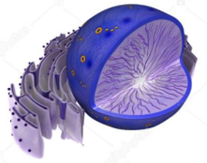
The Nucleus is the ________________ of the cell. The nucleus contains __________ or ___________________. DNA dictates ____________________________ and how it is going to do it (through controlling the production of proteins).
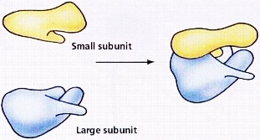
Ribosomes make __________ from amino __________.

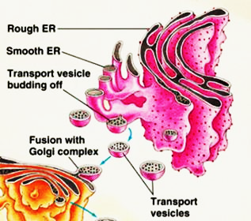
Rough Endoplasmic Reticulum (rER)has ___________ attached to it. The Smooth Endoplasmic Reticulum (sER) has no ribosomes attached to it
The Endoplasmic Reticulum is for ______________ ____________ such as ____________. The protiens and other materials are transported away from the ER in small __________ , which travel to the golgi apparatus.
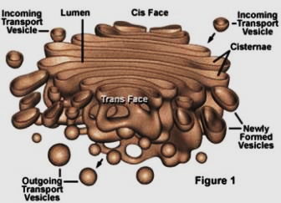
The Golgi Apparatus sometimes called the _________ ___________. It is responsible for the ___________ of proteins and the addition of ___________ and _________________ to them.
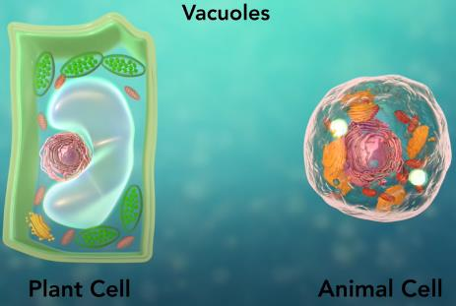
The Vacuole are _____ ______ ___________ that store ___________ ___________ and ___________. Vacuoles are especially important in plant cells as they provide internal support to cell rigidity. When a vacuole shrinks through water loss you can see the leaves of the plant wilt.
Lysosomes are the ____________ ___________. They take in ____________ or _______________ cell parts. Lysomes contain (are filled with) ______________ which breakdown this ________________________.
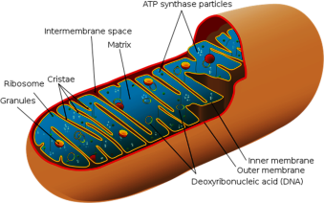
Mitochondria are the ______________ of the cell. During _____________ ______________ the mitochondria make ATP molecules which provide all of the ____________ the cell needs. Cells which need more ___________ have more __________________.
The Cytoskeleton holds the threadlike ________________ and _______________ which help hold the cell together.
Chloroplasts is where ______________ occurs. This is where carbon dioxide and water are converted to glucose and oxygen. Chloroplasts are green because they contain ___________________.

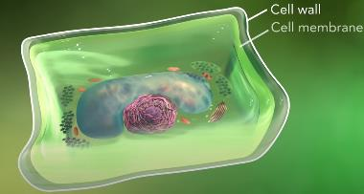
Plant cells also have a cell wall. A cell wall is outside the cell ________________ and it shapes, __________, and ____________ the plant cell. It is made of cellulose, a tough protein.

